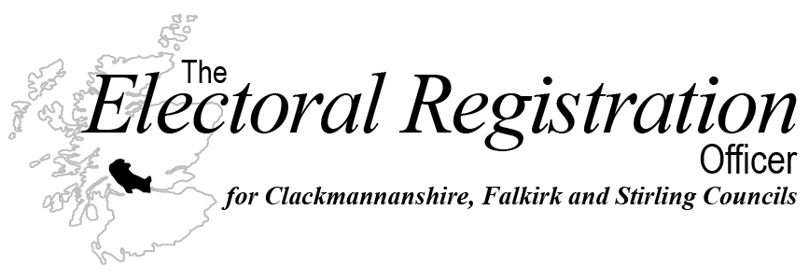

What does registering to vote mean to you?

Write a word or phrase on a post-it and add a leaf to our Democra-tree!

